**Dumbbell Exercises**

**Dumbbell Exercises for Your Arms**

**Dumbbell Wrist Curl**

* Sit with your forearms resting on your thighs, holding a dumbbell in each hand with your palms facing up.
* Position your wrists so they are just beyond your knees.
* Start with your wrists down, dumbbells resting on your fingers.
* In one movement curl your fingers up followed by your wrists.
* Hold for 2 seconds then lower back down.

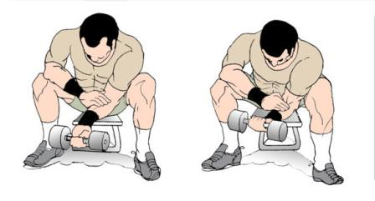

**Dumbbell Bicep Curl**

* Stand up straight with your feet shoulder width apart, knees slightly bent, core muscles braced, shoulders back and down.
* Hold the dumbbells down by your sides, palms facing in (towards your body). Your elbows should stay fixed to your side throughout.
* Focus on your biceps, breathe in and lift the dumbbells by bending at your elbow.
* As you lift, turn your palms to face up.
* Exhale and slowly bring the dumbbells back down to the starting position, keeping full control of the movement.

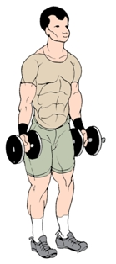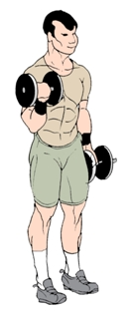

**Dumbbell Exercises: Tricep Extension**

* Sit on a bench or chair (or stability ball for more of a challenge).
* Holding 1 dumbbell with both hands (so that it's vertical to the floor), straighten your arms above your head (keeping elbows slightly bent).
* Engage your core muscles to keep your back straight.
* Breathe in and slowly lower the dumbbell behind your head, bending at your elbows.
* Keeping focused on your triceps exhale and slowly lift the dumbbell back up to the starting point.

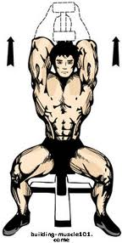

**Dumbbell Exercises for Your Chest**

**Dumbbell Bench Press**

* Lie on a bench, your arms up over your chest holding both dumbbells with palms facing forward.
* Keep your feet flat on the floor and your back in neutral (no more than a slight arch).
* Breathe in and lower the dumbbells by bending your elbows out to the sides. Keep going until your elbows are just below your shoulders.
* Exhale and press the dumbbells back up, bringing them close together at the top (without touching), and angled slightly inwards. Keep a slight bend in your elbows, don't allow them to "lock".
* Workout for chest can also be distributed as Incline and Decline in which Incline works on upper chest and decline works on lower chest.
* For Incline and Decline use the inclined and declined bench respectively.

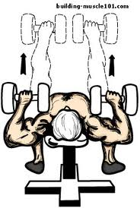

**Dumbbell Exercises for Your Shoulders**

**Dumbbell Shoulder Press**

* Standing or sitting, hold each dumbbell at head height (upper arms parallel to the floor, elbows bent at 90 degrees) and palms facing forward.
* Make sure your back is straight (and not overly arched).
* Brace your core muscles, and keep your knees slightly bent.
* Breathe in and slowly press the dumbbells straight up over your head.
* Hold for 1 or 2 seconds, exhale and bring it back down to the starting position.

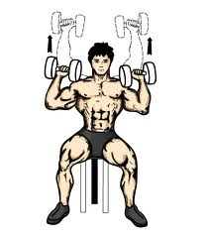

**Dumbbell Lateral Raise**

* Stand with your feet shoulder width apart, knees slightly bent.
* Hold a dumbbell with each hand by your side, palms facing in. Brace your core and keep a slight bend in your elbows throughout.
* Breathe in and Slowly raise both dumbbells out to the sides. As you reach shoulder height, tilt the front of the dumbbells down slightly (so that your little finger is the highest point). This will ensure your elbows stay above your wrists, keeping the work on the middle and rear shoulders.
* Pause as you reach shoulder height, exhale and then slowly come back down. Don't relax at the bottom of the rep, go straight into the next one.

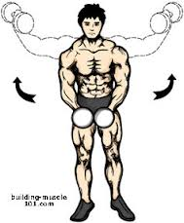

**Dumbbell Exercises for Your Back**

**Dumbbell Pullovers**

* Lie across a bench (so that only your upper back, shoulders and neck are resting on the bench).
* Keep your back neutral, head still and both feet flat on the floor (knees bent at 90 degrees).
* Hold the dumbbell over your chest with both hands. Keep your elbows slightly bent.
* Breathe in and slowly lower the dumbbell back and behind your head. Feel the stretch further by lowering your hips a little at the bottom of the lift.
* Exhale and slowly lift the dumbbell back up above your chest.

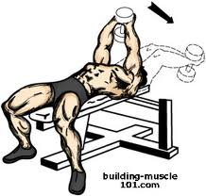

**Dumbbell Row**

* Place the dumbbell to the right of the bench.
* Place your left knee on the bench, keep your right foot on the floor beside the bench with knee slightly bent.
* Bend forward from your hips, keeping your back straight and parallel to the floor. Rest your left hand at the top of the bench.
* Breathe in and pick the dumbbell up in your right hand, palm facing in.
* Row the dumbbell up by bending at your elbow. Keep going until your elbow is level with (or just beyond) your back.
* Exhale and then slowly lower it down.
* Complete all reps on one side then repeat on the opposite side.

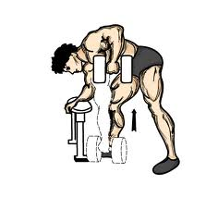

**Dumbbell Exercises: Shrug**

* Stand holding the dumbbells down by your sides, palms facing in.
* Breathe in and shrug your shoulders straight up.
* Exhale and come back straight down (don't roll them forward or back).

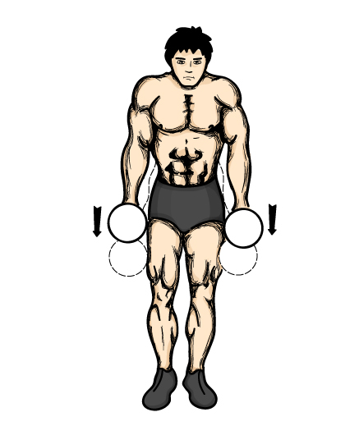

**Dumbbell Exercises for Your Core, Butt and Legs**

**Dumbbell Exercises: Side Bends**

* Stand with your feet shoulder width apart and knees very slightly bent (you should never stand with your knees locked).
* Hold the dumbbell in your right hand, palm facing in. Keep your right arm straight throughout, rest your left hand on your waist.
* Breathe in and slowly bend to the right from your waist, exhale and then back up.
* Breathe in and slowly bend to the left from your waist, exhale then back up.
* Complete your reps then repeat with the dumbbell in your left hand.

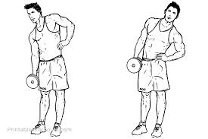

**Dumbbell Exercises: Wide Squat**

* Hold a dumbbell at the top of your upper back with both hands.
* Stand with your feet wider than shoulder width apart, toes pointed forward and your back straight.
* Breathe in and bend your knees and go down into the squat by using your glutes to stick your butt backwards (like you're about to sit down).
* Keep going until your knees are almost at 90 degrees. Keep your knees pointed in the same direction as your feet.
* Exhale and return back up by pushing with your butt, hams and quads.

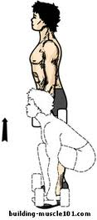

**Dumbbell Lunge**

* Hold a dumbbell in each hand by your side and stand with feet shoulder width apart.
* Take a large step forward with your left foot. Keep your right foot grounded for balance, breathe in and bend both knees so that your body is lowered straight down.
* Keep your back straight and upright throughout.
* Exhale and Use the front leg to return back up and step back.
* Alternate legs for each rep.

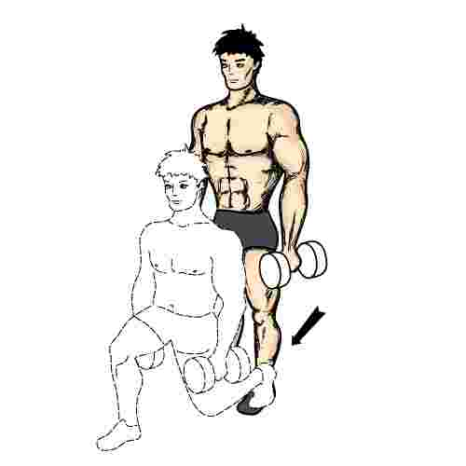

**Dumbbell Exercises: Calf Raises**

* Hold a dumbbell in your right hand down by your side.
* Stand on the floor, wrap your left foot around the back of your right ankle.
* Keep your right leg straight (without locking knees). Focus on your core muscles to stay balanced.
* Raise onto the ball of your right foot, moving only at your ankle.
* Then slowly come back down, keeping your balance without rocking back onto your heel.
* Complete your reps and then repeat with your left foot (holding dumbbell in your left hand).

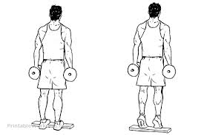

**Dumbbell Exercises for Your Whole Body**

**Dumbbell Exercises: Deadlift**

* Stand directly behind the dumbbells with your feet shoulder width apart.
* Squat down by pushing your butt back, bending the knees and keeping your back straight.
* Grip the dumbbells (overhand) with elbows outside knees.
* Breathe in and use your legs, butt, upper back and arms to burst up to standing.
* Pause for a second exhale and return back down, making sure your back remains flat.

